Caythorpe Primary School
Handwriting Policy
Date of policy: May 2021
Review date: May 2022

Introduction
This handwriting policy is for staff, parents, carers, students and visitors. It is intended to provide a clear framework for a shared understanding of teaching handwriting and ensuring continuity across the school. Handwriting is the skill of fluid movement where memory holds the shapes because it has made them so often. This is why children need to be taught through demonstration, explanation and practice. The correct formation of letters needs to be automatic before children can move to learn a fluent, joined handwriting style.

Aims of the Penpals Handwriting Scheme
Formal handwriting skills will be taught regularly and systematically through the use of the Penpals Handwriting scheme (Cambridge University Press). Five stages are identified and these form the basic organisation of the scheme:
1. Readiness for writing: gross and fine motor skills leading to letter formation (Foundation Stage-Nursery and Reception)
2. Beginning to join (Lower KS1- Yr1 and 2)
3. Securing joins (Upper KS1/Lower KS2- Y2 and Y3)
4. Practising speed and fluency (Lower KS2- Y3 and Y4)
5. Presentation skills (Upper KS2- Y5 and Y6)
Opportunities for linking handwriting with early phonics and spelling work are fully exploited through the Penpals scheme.

Posture
Children should be taught the importance of sitting upright and correctly on their chair, with their feet on the floor.

Pencil grip
Children should use a tripod grip. Children should be shown how to place their pencil on the table in front of them with it pointing towards their bodies and to then pick it up and allow the pencil to fall back into the tripod grip.

The Sassoon Font
Penpals uses the Sassoon font. All classes will have the appropriate font (before or after joining) displayed in their classroom. It is cursive, but not fully cursive.
This means it:
- Does not start on the line with the lead in but the letters do have the exit flicks.
- Does not loop the f, g or y.
- Teaches the ‘k’ with a loop.
- Capital letters stand alone and are not joined to the next letter
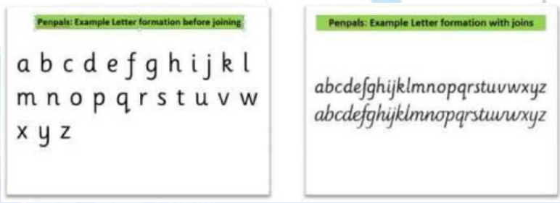

Handwriting teaching in the Early Years Foundation Stage

In the Foundation Stage children need to develop skills which will later enable them to acquire a legible, fluent and fast handwriting style. In nursery and reception children will develop:
- Gross and fine motor skills through sensory activities
- Recognition of pattern and language to talk about shapes and movement e.g. forming shapes and letters in sand/ shaving foam
- Shaping of patterns and basic letter movements
- A comfortable tripod pencil grip (between the thumb and forefinger with the pencil resting on the third finger) that allows for efficient control of the pencil
- Correct formation of all lower case letters (taught through Phonics)

Teaching Handwriting in Key Stage 1 and 2
The highest priority is given to teaching the correct letter formation before any attempt is made at joining. All pupils have at least one 20 minute handwriting lesson per week with further ‘short burst’ opportunities to revisit and practise skills.
Key Stage 1 Children will continue to develop fine and gross motor-skills with a range of multi -sensory activities. Teachers and support staff continue to guide children on correct letter formation using a comfortable tripod pencil grip that allows for efficient control. Through the Penpals scheme children will begin to learn how to join letters in Year 1 and continue to practice this skill in Year 2.

Key Stage 2
Children will continue to have regular practice of handwriting, securing the joins and developing speed and fluency. By the end of Year 6 pupils should have a clear, fluid handwriting style. Children will have the opportunity to earn a ‘pen licence’ from Year 3 upwards and may use a handwriting pen rather than pencil at the discretion of the teacher.

Handwriting Feedback
Marking should be timely and relevant. Teaching staff should give immediate feedback during handwriting lessons, modelling correct formation and joins in pupil’s books before giving opportunity for the pupil to practise.

Assessment and Progress over time
On-going assessment in handwriting gives the chance to spot errors or inconsistencies that are likely to impede a fast, fluent handwriting style. For pupils in KS1 there is a beginning of year assessment (in Penpals teacher handbook) which assesses the previous year’s work and gives an indication of what needs to be consolidated before beginning new work. Teachers in KS1 will use these at the start of the academic year. From Yr3 onwards the final unit in each book can be used as the basis of a summative assessment. Teachers will make a summative assessment of pupils by answering these questions in relation to the end of year expectations for their year group:
- Are all letters formed correctly?
- Are letters consistently sized?
- Are the known joins used?
- Are the known joins used correctly?
- Are ascenders and descenders parallel?
- Are the spaces within and between words regular?
- Is good handwriting carried over into other areas of the curriculum?
- What are the next handwriting targets for this child?

Inclusion
Left handed pupils (approximately 10% of the population) are supported by being encouraged to:
- Turn their paper to the right rather than the left
- Sit on the left-hand side of a right-handed child so they have enough space
- Position their paper to keep the wrist straight and their hand below the writing line

The vast majority of pupils are able to learn to write legibly and fluently. However, some pupils need more support. Children who are not yet ready to write are provided with a range of pre-writing activities (see Foundation 1 and Foundation 2 Penpals teacher handbooks). Further intervention may be arranged with specialist advice from the SENCo and the Occupational Therapist who may provide targeted support for individual children. Additional resources will be provided by the SENCO where deemed necessary such as sloping surfaces, special seat cushions and pencil grips.

Teacher handwriting

Teacher and teaching assistants’ handwriting in pupil’s books is expected to follow the Penpals Sassoon font at the expected stage for their year group. We expect all staff to work towards using the school font as consistently as possible.

Partnership with Parents and Carers

Penpals provides information sheets for parents/ carers so that they can support at home. These are available as downloads for each year group from the school website.

This policy is a working document.

