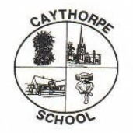
Geography At Caythorpe Primary School
At Caythorpe we believe the study of geography is about more than just memorising places on a map. It’s about understanding the complexity of our world, appreciating the diversity of cultures that exist across continents. And in the end, it’s about using all that knowledge to help bridge divides and bring people together.
The geography curriculum at Caythorpe identifies the knowledge and skills that pupils are to learn. Like many subjects, knowledge in geography can be organised into 2 forms:
Substantive knowledge sets out the content that is to be learned. The national curriculum and other geography education literature presents this through 4 interrelated forms:
- locational knowledge
- place knowledge
- human and physical processes (the geography community also includes ‘environmental’ as part of this)
- geographical skills.
Disciplinary knowledge considers how geographical knowledge originates and is revised. It is through disciplinary knowledge that pupils learn the practices of geographers.
A successful geography curriculum reflects teachers’ careful thought about what is to be taught, the rationale for it, the sequencing of learning and the relationships between the forms of knowledge. With this in place, pupils are likely to know, remember and be able to do more.
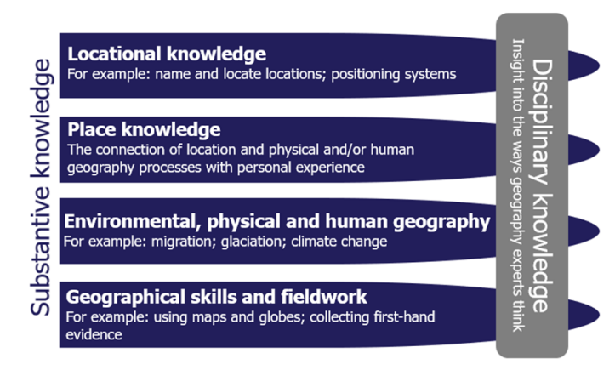
‘Knowing where’s where’ is one of the mainstays of geographical education. In building pupils’ locational knowledge, teachers recognise that this not only helps pupils to identify specific features but also to: build their own identity and develop their sense of place develop an appreciation of distance and scale learn about the orientation of the world, including references such as the continents and oceans that they can navigate from
Curriculum progression
A high-quality geography education brings together careful selection of content, organisation of that content, choice of teaching approaches, assessment and other factors. The geography curriculum maps out the knowledge that pupils learn to gain geographical expertise. In planning the curriculum, the nature of the discipline should inform content and activity choices to ensure that pupils learn and can consider their own answers to geographical questions. (From Ofsted Research review series: geography Published 17 June 2021)

Progression of Skills In Geography
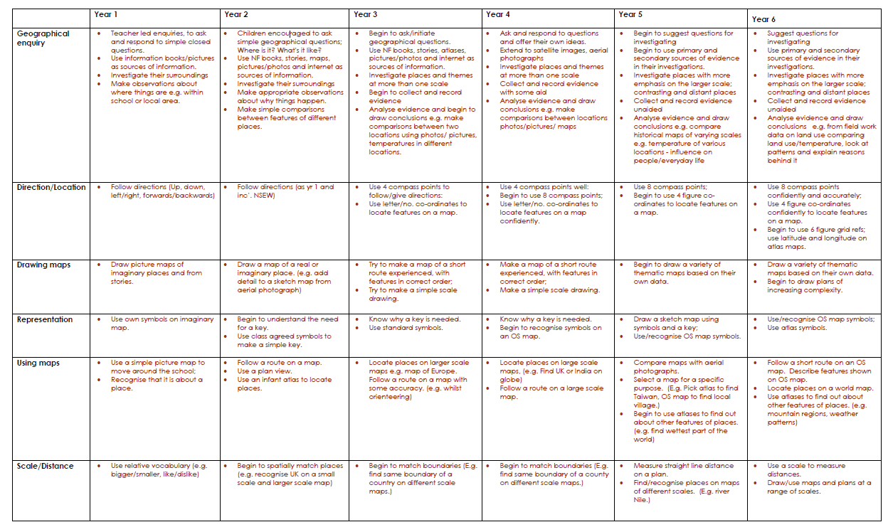
High-quality geography education may have the following features
Locational Knowledge: Pupils gain a secure knowledge of distance, orientation, scale and positioning systems, which begins in the early years. This gives them the framework they need to understand locational knowledge. ‘Knowing where’s where’ supports pupils’ identity and sense of place and contributes to their understanding of geographical processes.
Over time, pupils learn and remember more locational knowledge. They become increasingly fluent in identifying specific locations.
Place Knowledge: Place knowledge is prioritised in the geography curriculum. It brings meaning to locations and processes studied. The curriculum and teachers’ plans build pupils’ knowledge of place by linking to places pupils already know or are familiar with. This may be from their personal experience as well as through what they have been taught. The curriculum gives pupils the knowledge they need to develop an increasingly complex understanding of place. Their understanding of place helps them to connect different aspects of geography. It also gives them different perspectives through which to consider the content studied.
The curriculum builds pupils’ place knowledge over time. This allows them to make meaningful comparisons.
Environmental, human and physical processes: Increasingly detailed knowledge of physical and human processes allows pupils to describe and explain different environments. Through this, pupils develop an appreciation of interconnectedness. Component knowledge is identified precisely and sequenced so that pupils first learn underpinning phenomena before moving on to more complex, multi-variate processes. This allows pupils to fully understand a wide range of environmental, human and physical processes. Over the course of study, pupils learn about processes that they are less familiar with or that are less visible. The curriculum ensures that older pupils are able to take a broader view, generalise, and critique models that represent specific processes.
Geographical Skills and Fieldwork: Pupils’ procedural knowledge (geographical skills) allows them to gather, analyse, present and interpret spatial information. In doing so, they are adept at identifying patterns and trends. Pupils have the specific skills they need to represent and interpret geographical data. These skills are integrated into the curriculum so that pupils understand their application. Repeated practice of geographical skills improves pupils’ fluency and accuracy. Fieldwork includes data collection, analysis and presentation.
The experience of fieldwork draws together pupils’ locational knowledge and that of human and physical processes. It supports pupils to appreciate the interplay between them.

“Thinking Like a Geographer”
Leaders who plan the curriculum appreciate that the body of knowledge covered by geography is vast. They make informed and careful choices about what is taught. This may go beyond the content prescribed in the national curriculum. For example, they may choose to explore particular phenomena that are prevalent in the locality.
The curriculum includes the most appropriate examples and case studies to demonstrate each aspect being learned. These are always real and relevant to the content. When introducing new component knowledge, teachers make sure that pupils can relate this to what they already know, so that they build a strong schema and so remember more. Teachers emphasise this interconnectedness between forms of knowledge to help pupils do this. Through careful curriculum design, each form of knowledge receives due consideration. Pupils build their knowledge both within the form and in how each form relates to others. Crucially, the interplay between each develops pupils’ secure geographical thinking. Leaders appreciate the structure of the subject, so their curriculum plans are constructed effectively to ensure that pupils know more, remember more and are able to do more.
How Knowledge is Remembered – Knowing more and remembering more
The knowledge pupils learn is well organised with clear connections between components, which means they are more likely to remember it in the long term. The curriculum builds on pupils’ prior learning and re-visits the content, which supports pupils in developing strong schemata.
Teachers avoid overloading pupils’ working memory. They break larger concepts or ideas into smaller ‘bite-size’ chunks and teach a small number of these Pupils commit knowledge to their long-term memory through recalling and repeated practice Pupils are efficient at carrying out tasks such as using grid references because they practise their procedural knowledge regularly.
Inclusion
Pupils with SEND generally study the same curriculum scope as other pupils.
Teachers have the same level of ambition for all pupils. They use specialist advice to adapt their teaching approaches where necessary. Teaching assistants are well briefed in the geography that is to be learned and the approaches taken. Teachers and specialists, including the SENCo, support them in their role. Classroom resources and fieldwork are adjusted as required to ensure that all pupils take part.

Assessment
See whole school assessment and reporting document for information on assessment of foundation subjects across the school.

