English | Spelling/Grammar
Narrative: Stories from other cultures  Non-Fiction: Debate/discussions and biographies | Year 3 – Nouns and paragraphs  Year 4 – Standard English and paragraphs
Maths | This term we are reading…
Fractions, money and time (Year 3)  Decimals, money and time (Year 4) | 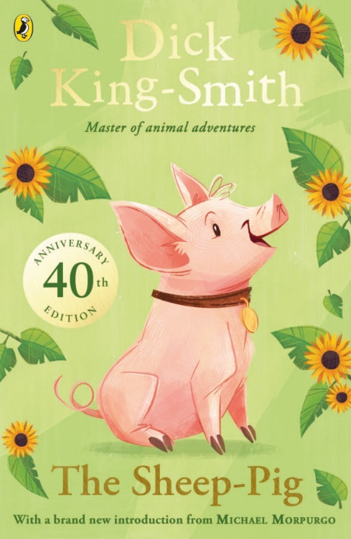
Computing
In this unit the children will develop their understanding of audio production. The children will identify the input device (microphone) and output devices (speaker or headphones) required to work with sound digitally. We will start to discuss the ownership of digital audio and the copyright implications of duplicating the work of others. The children will have chance to editing their work, adding multiple tracks, and opening and saving the audio files.
DT | Science
For Design and Technology this term we are going to be constructing photo frames. We will be looking at existing photo frames that are available then we will look at how they are constructed. The children will design their own photo frame and then have the chance to make it. After they have made the frame they will evaluate it. | The enquiry question for this term is ‘How do magnets interact?’ and it will involve the children learning how magnets react with each other. We will be investigating which materials are magnetic. We will learn about the magnetic poles and how opposite poles attract and the same poles repel. The children will set up a comparative test to see if the strength of a magnet effects how it behaves with magnetic materials
PE | RE
This will continue to be on a Monday and Tuesday, please ensure kit is in school from Monday each week. On Monday Year 3 and 4 children will be doing gymnastics. On Tuesday the children will be working on their athletic skills with Coach Abbie. | Narnia will be exploring the question ‘What is pilgrimage?’ in RE. Children will learn about where Christians, Muslims and Hindus pilgrimage to and why. We will also look at why non-religious pilgrims and why that special journey may be carried out.
Music | French
‘Enjoying improvisation’ is theme for music this term and the children will learn new songs and the children will have the opportunity to improvise with parts of the songs. | In French this term the children will be looking about the topic of ‘presenting myself’.
Geography | Big Bang
The enquiry question for this term is ‘Where is Caythorpe in the World?’ and will involve the children studying about the time zones and how the earth is split up into northern hemisphere and southern hemisphere. The children will also learn the position and significance of Tropics of Cancer and Capricorn and the Arctic and Antarctic circle. | For we will be explorers looking all around the world. We will specifically look at Antarctic explorers Shackleton, Scott & Amundsen to history of the race to the North pole this will link to our English topic of recounts later in the term.
PSHE
This term’s learning will focus on children ‘Relationships’ The unit of learning will help the children to know how to identify jealous in a situation and strategies to problem solve when this happens. Being able to identify someone that they love and why they are special to them. The children will be able to recognise how friendships change, know how to make new friends and how to manage when I fall out with my friends.
Dates for your diary | Useful Links
Monday 16th April 2024 – Term 5 Begins.  Thursday 18th April 2024 – FSA Film Night  Monday 6th May 2024 – Bank Holiday  Thursday 24th May 2024 – Term 5 Ends. | More information can always be found on the Narnia class page on the school website.  Times Table Rockstars – Playing this little and often will have a great effect on their ability to access mathematics within the classroom.  Hit the Button – This is a great free online platform, which can help children with their number bonds, multiplication facts, division facts and much more.
You can keep up to date with what the children are learning on our curriculum webpages, Twitter and Caythorpe School Facebook page, but please do not hesitate to speak to me before and after school or send a message via ClassDojo.
Thank you for your continued support.
Miss Houlden

